|  |  |  |  |  |  |
| --- | --- | --- | --- | --- | --- |
| **Group Statistics** | | | | | |
|  | GROUP | N | Mean | Std. Deviation | Std. Error Mean |
| ACCURACY | DT | 10 | 98.2020 | .58353 | .18453 |
| SVM | 10 | 94.7200 | .76056 | .24051 |

|  |  |  |  |  |  |  |  |  |  |  |  |
| --- | --- | --- | --- | --- | --- | --- | --- | --- | --- | --- | --- |
| **Independent Samples Test** | | | | | | | | | | | |
|  | | Levene's Test for Equality of Variances | | t-test for Equality of Means | | | | | | | |
| F | Sig. | t | df | Sig. (2-tailed) | Mean Difference | Std. Error Difference | 95% Confidence Interval of the Difference | |
| Lower | Upper |
| ACCURACY | Equal variances assumed | .541 | .471 | 11.486 | 18 | .000 | 3.48200 | .30314 | 2.84512 | 4.11888 |
| Equal variances not assumed |  |  | 11.486 | 16.869 | .000 | 3.48200 | .30314 | 2.84205 | 4.12195 |

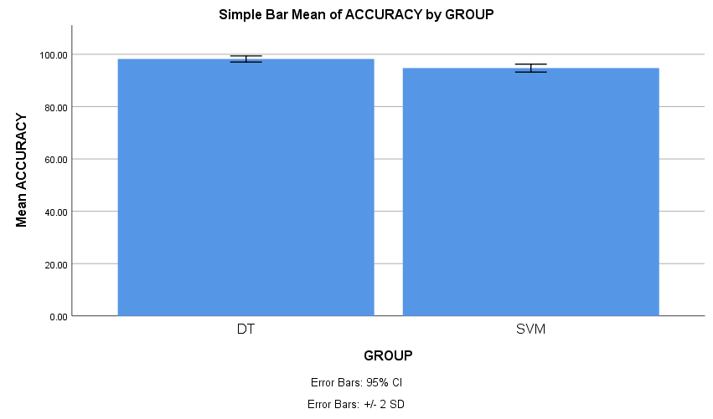

|  |  |  |  |  |  |
| --- | --- | --- | --- | --- | --- |
| **Group Statistics** | | | | | |
|  | GROUP | N | Mean | Std. Deviation | Std. Error Mean |
| ACCURACY | RF | 10 | 97.0790 | .94658 | .29933 |
| SVM | 10 | 94.7200 | .76056 | .24051 |

|  |  |  |  |  |  |  |  |  |  |  |
| --- | --- | --- | --- | --- | --- | --- | --- | --- | --- | --- |
| **Independent Samples Test** | | | | | | | | | | |
|  | | Levene's Test for Equality of Variances | | t-test for Equality of Means | | | | | | |
| F | Sig. | t | df | Sig. (2-tailed) | Mean Difference | Std. Error Difference | 95% Confidence Interval of the Difference | |
| Lower | Upper |
| ACCURACY | Equal variances assumed | .445 | .513 | 6.143 | 18 | .000 | 2.35900 | .38399 | 1.55227 | 3.16573 |
| Equal variances not assumed |  |  | 6.143 | 17.202 | .000 | 2.35900 | .38399 | 1.54958 | 3.16842 |

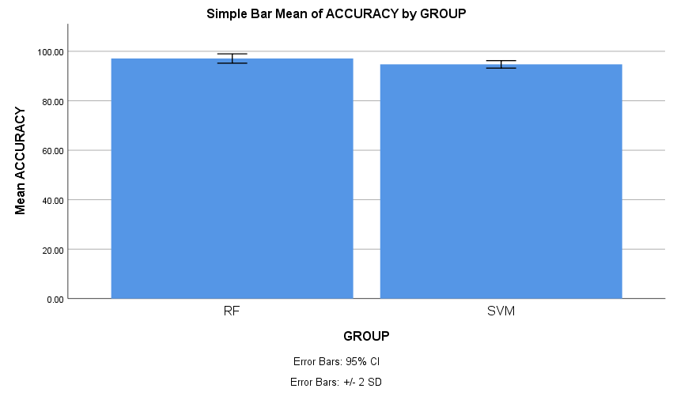

|  |  |  |  |  |  |
| --- | --- | --- | --- | --- | --- |
| **Group Statistics** | | | | | |
|  | GROUP | N | Mean | Std. Deviation | Std. Error Mean |
| ACCURACY | KNN | 10 | 94.4960 | .98524 | .31156 |
| SVM | 10 | 94.7200 | .76056 | .24051 |

|  |  |  |  |  |  |  |  |  |  |  |  |
| --- | --- | --- | --- | --- | --- | --- | --- | --- | --- | --- | --- |
| **Independent Samples Test** | | | | | | | | | | | |
|  | | Levene's Test for Equality of Variances | | t-test for Equality of Means | | | | | | | |
| F | Sig. | t | df | Sig. (2-tailed) | Mean Difference | Std. Error Difference | 95% Confidence Interval of the Difference | |
| Lower | Upper |
| ACCURACY | Equal variances assumed | .858 | .366 | -.569 | 18 | .576 | -.22400 | .39359 | -1.05090 | .60290 |
| Equal variances not assumed |  |  | -.569 | 16.916 | .577 | -.22400 | .39359 | -1.05472 | .60672 |

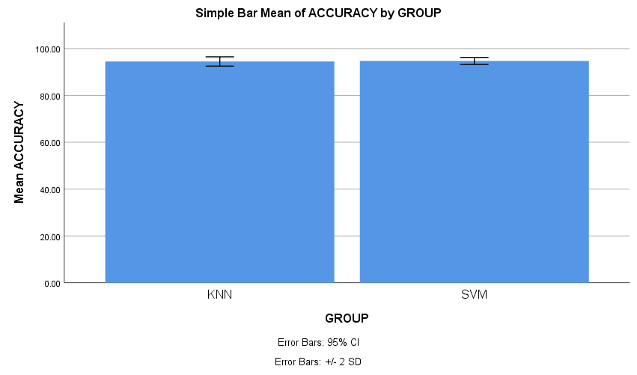

|  |  |  |  |  |  |
| --- | --- | --- | --- | --- | --- |
| **Group Statistics** | | | | | |
|  | GROUP | N | Mean | Std. Deviation | Std. Error Mean |
| ACCURACY | XGB | 10 | 96.2930 | 2.31289 | .73140 |
| SVM | 10 | 94.7200 | .76056 | .24051 |

|  |  |  |  |  |  |  |  |  |  |  |  |
| --- | --- | --- | --- | --- | --- | --- | --- | --- | --- | --- | --- |
| **Independent Samples Test** | | | | | | | | | | | |
|  | | Levene's Test for Equality of Variances | | t-test for Equality of Means | | | | | | | |
| F | Sig. | t | df | Sig. (2-tailed) | Mean Difference | Std. Error Difference | 95% Confidence Interval of the Difference | |
| Lower | Upper |
| ACCURACY | Equal variances assumed | 15.970 | .001 | 2.043 | 18 | .056 | 1.57300 | .76993 | -.04456 | 3.19056 |
| Equal variances not assumed |  |  | 2.043 | 10.924 | .066 | 1.57300 | .76993 | -.12304 | 3.26904 |

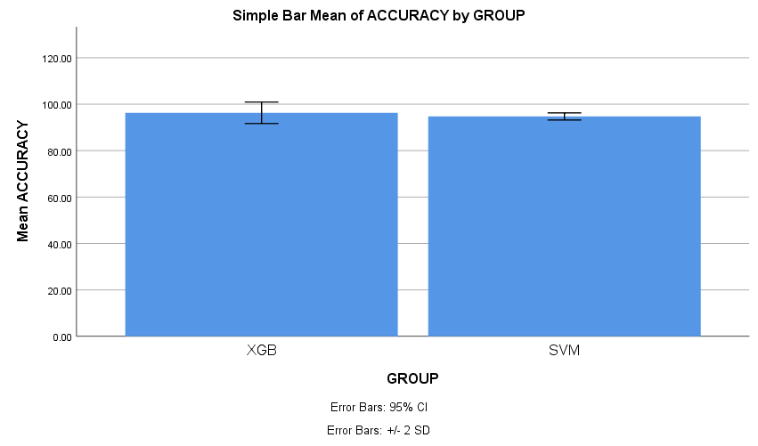

Title-1: "Evaluating the precision of Random Forest vs Support Vector Machines for Forecasting Job Rescission in the Industry."

Title-2: ‘’A Comparative Analysis of Decision Tree and Support Vector Machines for Predicting Job Rescission in the Industry"

Title-3:"Enhancing Job Rescission Forecasting: XGBoost vs. Support Vector Machines Performance Evaluation"

Title-4:"Assessing the Predictive Accuracy of K-Nearest Neighbors vs. Support Vector Machines for Job Rescission Forecasting"

|  |  |  |
| --- | --- | --- |
| **S.NO** | **RANDOM FOREST ACCURACY (%)** | **SUPPORT VECTOR MACHINE ACCURACY (%)** |
| 1 | 97.75 | 94.38 |
| 2 | 97.75 | 93.26 |
| 3 | 98.88 | 95.51 |
| 4 | 96.63 | 95.51 |
| 5 | 96.63 | 94.38 |
| 6 | 96.63 | 94.38 |
| 7 | 95.51 | 95.51 |
| 8 | 96.63 | 94.38 |
| 9 | 96.63 | 95.51 |
| 10 | 97.75 | 94.38 |
| **S.NO** | **DECISION TREE ACCURACY (%)** | **SUPPORT VECTOR MACHINE ACCURACY (%)** |
| 1 | 97.75 | 94.38 |
| 2 | 97.75 | 93.26 |
| 3 | 97.75 | 95.51 |
| 4 | 97.75 | 95.51 |
| 5 | 98.88 | 94.38 |
| 6 | 98.88 | 94.38 |
| 7 | 97.75 | 95.51 |
| 8 | 98.88 | 94.38 |
| 9 | 98.88 | 95.51 |
| 10 | 97.75 | 94.38 |

|  |  |  |
| --- | --- | --- |
| **S.NO** | **XGBOOST ACCURACY (%)** | **SUPPORT VECTOR MACHINE ACCURACY (%)** |
| 1 | 97.75 | 94.38 |
| 2 | 97.75 | 93.26 |
| 3 | 98.88 | 95.51 |
| 4 | 96.63 | 95.51 |
| 5 | 96.63 | 94.38 |
| 6 | 96.63 | 94.38 |
| 7 | 95.51 | 95.51 |
| 8 | 96.63 | 94.38 |
| 9 | 96.63 | 95.51 |
| 10 | 97.75 | 94.38 |

|  |  |  |
| --- | --- | --- |
| **S.NO** | **KNN (%)** | **SUPPORT VECTOR MACHINE ACCURACY (%)** |
| 1 | 97.75 | 94.38 |
| 2 | 97.75 | 93.26 |
| 3 | 97.75 | 95.51 |
| 4 | 97.75 | 95.51 |
| 5 | 98.88 | 94.38 |
| 6 | 98.88 | 94.38 |
| 7 | 97.75 | 95.51 |
| 8 | 98.88 | 94.38 |
| 9 | 98.88 | 95.51 |
| 10 | 97.75 | 94.38 |